
YEAR PHYSICS 11 MOTION TEST 1 November 2014

Total Marks = [50] Time: 50 mins

NAME:

Question 1 (2 marks)

A farmer walked 745 m West from a gate to repair a fence post. When that job was finished
he turned around and walked 984 m East to repair another part of the fence. Draw and label a vector diagram of his total journey then calculate his resultant displacement.

Question 2 (2 marks)

If the total time spent walking by the farmer was 30 minutes, calculate his average velocity and his average speed?
Question 3 (6 marks)

The velocity–time graph for a remote control car is shown below.

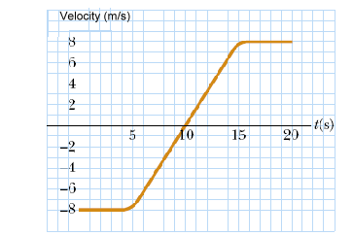
    - What is the velocity and acceleration of the car at t =10s? [2 marks]

    - In the space to the right of the graph plot a graph of the acceleration of the car against time. [2 marks]
    - Determine the displacement of the car in the time from t = 5 s to t = 20 s. [2 marks]

Question 4 (4 marks)

A runway at a small airport is 1220 m long. A light aircraft accelerates at 0.785 m s^{–2} along this runway, starting at one end and taking off 200 m before reaching the other end. If the aircraft was initially stationary, calculate its speed when it took off.

Question 5 (12 marks)
A car of mass 1600 kg left parked on a steep but rough road begins to roll down the hill. After a short while it reaches a constant speed. The road is inclined at 15° to the horizontal. Its speed is sufficiently slow that the air resistance is insignificant and can be ignored.
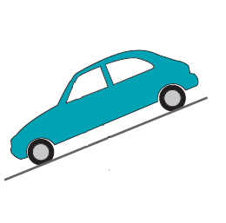a. Draw in the forces acting on the car when it is parked.
[3 marks]
b. Determine the component of the car’s weight that acts
parallel to the road AND the component that acts perpendicular to the road. [2 marks]
c. Is there a net force acting on the car when it is parked? Explain. [1 mark]

c. Is there a net force acting on the car when it is rolling down the hill at constant velocity? Explain.
[2 marks]

d. What is the value of the normal reaction force that the road exerts on the car AND the value of road friction when it is rolling down the hill at constant velocity?
[2 marks]
e. As the car comes out of the hill onto the flat road at the base of the hill, what happens to the value of the normal reaction force? Explain. [2 marks]
Question 6 [8 marks]

Two physics students, James and Jordan, conduct the following experiment from a very high bridge. James drops a 1.5 kg shot-put from a vertical height of 60.0 m while at exactly the same time Jordan throws a 100 g mass with an initial downwards velocity of 10.0 m s^{–1} from a point 10.0 m above James.

Calculate the time that:

- the shot-put takes to reach the ground [2 marks]
- the 100 g mass takes to reach the ground. [2 marks]
- At what time will the 100 g mass overtake the shot-put? [2 marks]
- Explain why the acceleration of the shot put and the 100 g mass are the same, even though the shot put is heavier. [2 marks]

Question 7 [6 marks]

Free-body diagrams are diagrams used to show the relative magnitude and direction of all forces acting upon an object in a given situation. Draw a free body diagram for each of the situations shown below:

- An egg is free-falling from a nest in a tree. Neglect air resistance. [2 marks]
- A book is at rest on a tabletop.
[2 marks]
- As a result of a flat battery, Mr Reberger’s car is towing Mr Robinson’s with a tow rope at a constant velocity. Draw a free body diagram of the forces acting on Mr Robinson’s car
[2 marks]

Question 8 [4 marks]

The photographs below show a thermometer used to measure the temperature of a solution, and
a ruler measuring the length of a metal strip. For each photograph, record the measurement and
state the uncertainty of the measurement.
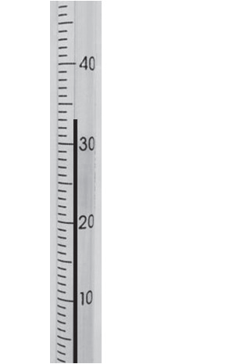
SCSA
- The temperature measured by the thermometer is __________ºC.
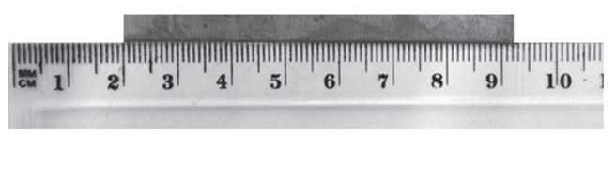
- The uncertainty is _________________ ºC.
SCSA

c. The length of the metal strip measured by the ruler is ____________ cm.
d. The uncertainty is ___________________cm.

Question 9 [6 marks]

A 70 kg fisherman is quietly fishing in a 40 kg dinghy at rest on a still lake when, suddenly, he is attacked by a swarm of wasps. To escape, he leaps from the boat into the water with a force of 140 N.

- What is the force acting on the boat? [1 mark]
- With what acceleration will the boat move? [2 marks]
- If the force on the fisherman lasted for 0.5 s, determine the speed attained by both the man and boat.
[3 marks]

